**PRESS-RELEASE Media contact:**

Valeriya Rybchak

SEPTEMBER 11, 2023 [valeriya.rybchak@itemf.ru](mailto:valeriya.rybchak@itemf.ru)

International Commercial Vehicle Show  
 05–08 September 2023

EXPOCENTRE, Moscow

[www.comtransexpo.ru](http://www.comtransexpo.ru)

**THE LARGEST COMMERCIAL VEHICLE SHOW COMTRANS 2023 HAS BEEN SUCCESSFULLY HELD IN THE CENTER OF MOSCOW**

The largest and most attended commercial vehicle trade show COMTRANS 2023 has been successfully held on September 5 – 8 сентября in the heart of the City of Moscow, at the Expocentre Fairgrounds.   
The show featured **242 exhibitors from Russia, Belarus, China, Turkey, and Iran**. The 17th edition of exhibition has been held in General Partnership with leading Russian automotive manufacturer KAMAZ.

Over 17 500 professionals from automotive and transport industries visited the exposition showcasing novelties including trucks, LCVs, buses, coaches, special utility vehicles, trailers, spare parts, and components.

Frist day of COMTRANS has been kicked off by the Winners ceremony of the most prestigious Gran Prix 2023 by leading Russian automotive publisher Za Rulem.

](https://www.vtb-leasing.ru/)  
The 2023’s Ceremony’s General sponsor is VTB Leasing.

**The Head of the Republic of Tatarstan Rustam Minnikhanov** visited COMTRANS 2023 on September 6th. He has admitted growing Russian commercial vehicle industry and plenty of innovations exhibited at the show.

**Russian Government Vice-Premier – Minister of Industry and Trade Denis Manturov** visited the show on September 7th.He stopped at the stands of all major OEMs and enjoyed detailed introduction of the first Russian electric low-floor LCV and new tourist coach ‘Cruise’ presented by the Modern Transport Technologies Group, new mid-size bus NEFAZ-4290, innovative electric bus KAMAZ-6282 and fully localized K5 generation of KAMAZ trucks, new tourist coach MAZ 350, tractor MAZ-541SA5 and dump truck MAZ-65262L by Minsky Automotive Plant, new URAL 80, URAL C34520 and innovative electric truck planform by URAL Automotive Plant, and many other novelties.

In the components section Denis Manturov stopped at the stand of AutoPribor showcasing new locally made gear motor, and at ITELMA’s exposition featuring locally designed and made electronic modules.

**COMTRANS 2023 intensive business program** ran in partnership and with participation of Russian Minpromtorg and Mintrans, Russian Union of Industrialists and Entrepreneurs, Russian Chamber of Commerce and Industry, International Road Transport Union IRU, Association of International Road Carriers ASMAP, Moscow Agglomeration Transport Association TAMA, Analytical Agency Autostat, National Gas Vehicle Association, AutoBoss Club, Montrans Group and AVITO Marketplace.

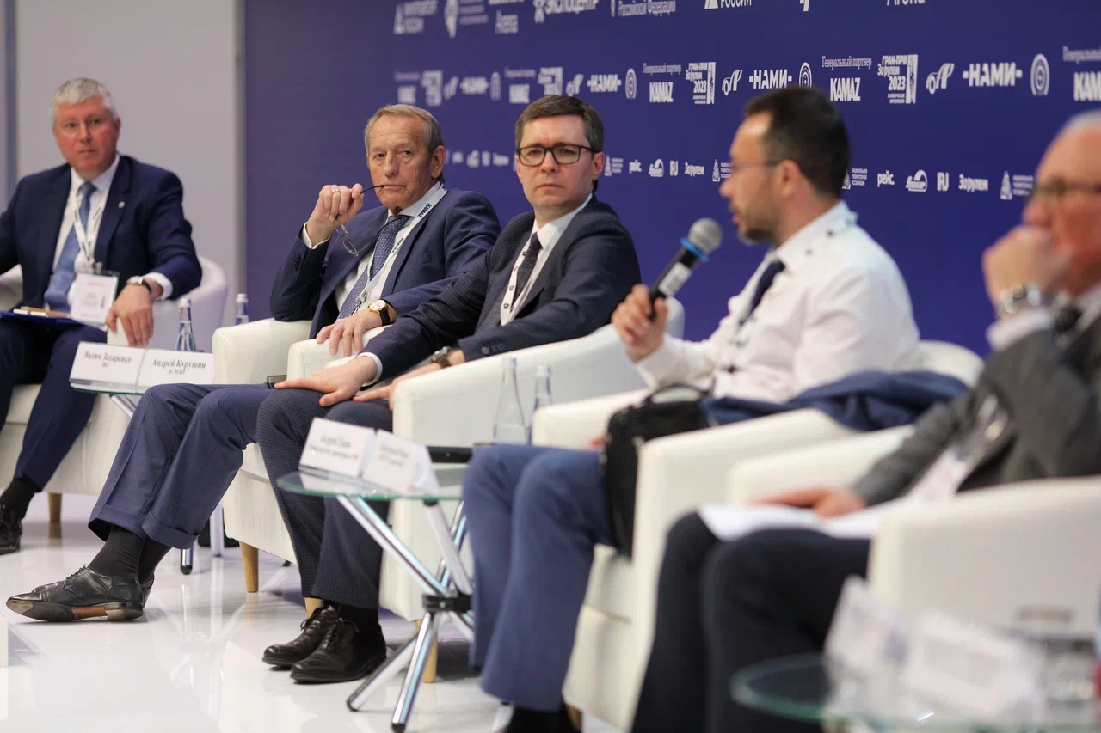  
In 4 days COMTRANS Arena featured more than 60 speakers and hosted more than 900 attendees in total.

**General partner**

](https://www.vtb-leasing.ru/)[**Awards` General Partner**](https://www.comtransexpo.ru/official-support/)

Organizers: General media-partner:

*COMTRANS is the largest international commercial vehicle show in Russia. Includes sectors: trucks and cargo LCV, buses and passenger LCV, utility vehicles, trailers and semi-trailers, spare parts and components. The organizers are: ITEMF Expo, a joint venture of two of Russia's largest exhibition organizers - ITE Group and Gefera Media, and the Association of Russian Automakers (OAR).*